**Software Engineering**

**Question Paper Set 1**

**Instructions: There are three sections. Answer all questions from each section. Each question carries 2 marks.**

**Section A (Recall)**

For each of the following questions only one of the options is correct. Choose the correct option.

* + 1. Unit testing is carried out during which phase of the waterfall model?

1. Coding phase
2. Testing phase
3. Maintenance phase
4. Design phase
   * 1. Which one of the following phases accounts for the maximum effort during development of a typical software?
5. Coding
6. Testing
7. Designing
8. Specification
   * 1. Which one of the following is not a principal factor contributing to faster software development under the RAD (Rapid Application Development) process model?
9. Visual style of development.
10. Use of reusable components.
11. Use of standard APIs (Application Program Interfaces).
12. Evolutionary development with iteration
    * 1. Which one of the following product views is implicit in an SRS document?
13. Black box
14. White box
15. Grey box
16. Glass box
    * 1. A software requirements specification (SRS) document should avoid discussing which one of the following?
17. Functional requirements
18. Non-functional requirements
19. Design specification
20. Constraints on the implementation
    * 1. The extent to which data exchanges take place between two modules during software execution is called which one of the following?
21. Coupling
22. Cohesion
23. Structure
24. Union
    * 1. For a given programming problem, a DFD model depicts which of the following?
25. Flow of data
26. Flow of control
27. Flow of decisions
28. Flow of atomic conditions
    * 1. The packing of data and functions into a single unit in a program is known as which one of the following?
29. polymorphism
30. abstraction
31. encapsulation
32. inheritance
    * 1. Which parts an informal (natural language) description of a programming problem is likely to represent objects in the solution domain?
33. All of the nouns and some of the verbs.
34. All of the verbs and some of the nouns.
35. Some of the nouns.
36. Some of the verbs
37. Consider the following statements regarding a developed software. Pick the correct statement.
    1. Every error causes a failure
    2. Every error causes a fault
    3. Every failure is caused by a fault
    4. Every bug causes a failure

**Section B**

For each of the following questions only one of the options is correct. Choose the correct option.

In which one of the following SDLC models, testing activities are spread over the entire development life cycle?

* 1. Iterative waterfall model
  2. V model
  3. Prototyping model
  4. Classical waterfall model

Defects get introduced into a work product due to mistakes committed by the members of the development team. A mistake in an activity pertaining to which one of the following phases is likely to be most expensive to correct when detected during system testing?

* 1. System testing
  2. Design
  3. Coding and unit testing
  4. Requirements analysis and specification

Which one of the following is not true of the prototyping model of software development?

1. The developed prototype is used to gain insights into the solution
2. The developed prototype is used to choose between alternatives
3. The developed prototype is used to elicit customer feedback.
4. The developed prototype evolves into deliverable software.

Elimination of which one of the following types of problems in the gathered requirements is not the focus of the requirements analysis task?

1. Inconsistency
2. Ambiguity
3. Incompleteness
4. Unstructuredness
   * 1. Which one of the following statements concerning the RAD (Rapid Application Development) model of software development is **FALSE**?
   1. It facilitates accommodation of change requests from the user
   2. Only short term plans are made
   3. It relies on heavy reuse of existing code.
   4. It is suitable for development of innovative products
      1. Which one of the following assertions is **FALSE** about functional requirements?
5. A functional requirement is also called a behavioural requirement
6. A functional requirement may consist of several scenarios of execution
7. A functional requirement is a statement of how certain inputs to program are mapped to the outputs
8. Some of the functional requirements specify the required system performance
   * 1. When a company plans to develop a generic product, who among the following is usually the source of the requirements?
9. Development team members
10. Project manager
11. Marketing personnel
12. Personnel from finance department
    * 1. Members of a Scrum team are not expected to answer which one of the following questions during a daily Scrum meeting?
13. What did you do yesterday
14. What will you do today?
15. What obstacles are in your way?
16. Why are you getting delayed?
    * 1. Which one of the following types of cohesion can be considered as the best form of cohesion?
17. Logical
18. Coincidental
19. Temporal
20. Functional
    * 1. Which one of the following best characterizes a sequence diagram?
21. A call graph illustrating all possible sequences of calls between class method members
22. A time-line illustrating a typical sequence of calls between object methods
23. A time-line illustrating the changes in inheritance and instantiation relationships between classes and objects over time
24. A tree illustrating inheritance relationship between classes
    * 1. Consider the following sentence: “A square is a polygon”. From an analysis of the sentence, identify the relations between the two classes Square and Polygon that can be inferred from the sentence.
25. Inheritance
26. Association
27. Aggregation
28. Composition
    * 1. What is the number of boundary classes required for a software development project whose use case diagram is shown below?

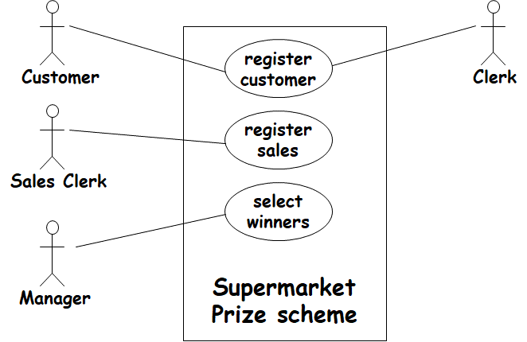

* 1. 3
  2. 4
  3. 6
  4. 8
     1. Which one of the following statements about Cyclomatic complexity metric of a program is **FALSE**?

1. It is a measure of the testing difficulty of the program.
2. It is a measure of understanding difficulty of the program.
3. It is a measure of the linearly independent paths in the program
4. It is a measure of the size of the program
   * 1. If branch coverage has been achieved on a unit under test, which one of the following coverages is implicitly achieved?
5. Path coverage
6. Multiple condition coverage
7. Statement coverage
8. Data flow coverage
   * 1. Alpha and Beta testing are considered to be which one of the following types of testing?
9. Regression testing
10. Unit testing
11. Integration testing
12. System testing

**Section C**

For each of the following questions only one of the options is correct. Choose the correct option.

Which one of the following activities undertaken during software development spans all stages of a software development life cycle (SDLC)?

1. Coding
2. Testing
3. Project management
4. Design

The operation phase of the waterfall model is a synonym for which one of the following phases?

1. Coding and unit testing phase
2. Integration and system testing phase
3. Maintenance phase
4. Design phase

High number of messages per use case would indicate which one of the following?

1. Good design --- there is satisfactory responsibility division among the classes
2. Poor design --- each method does very little work
3. Good design --- high degree of collaboration among the classes
4. Poor design --- violation of encapsulation

Which one of the following techniques can a manager use to estimate the number of errors still remaining in a program after all the testing activities are complete?

1. Mutation testing
2. Error seeding
3. Pair-wise testing
4. Cause-effect graphing
   * 1. Which one of the following is not a software service type of project?
5. A project for customization of an educational institute automation software
6. A project for maintenance of a generic accounting software package
7. A project for testing of a generic accounting software package
8. A project undertaken by a vendor to develop from scratch a novel plant automation software for a client
   * 1. Which one of the following is **not** a notable difference between a contemporary software project and a software project undertaken a couple of decades back?
9. Development of software requirements specification (SRS) document
10. Facilitation of customer participation in the project development work
11. Incremental software delivery with evolving functionalities at the customer site during software development.
12. Significant reuse and customization of software as part of software development
    * 1. Which one of the following statement regarding a computer systems engineering project is **false**?
13. These projects entail development of both software and hardware parts of the solution
14. Development of a coffee vending machine is an example of a computer systems engineering project
15. Development of a robotic toy is an example of a computer systems engineering project
16. Typically, in a computer systems engineering project the hardware is developed first and then the software part is developed.
    * 1. Which one of the following statements correctly characterizes the control flow structure of a program?
    1. The order in which the instructions of the program are executed
    2. The order in which statements appear under the control statements
    3. The order in which the control statements are laid out in the code
    4. The order in which the statements of the program are written by the programmer
       1. Which one of the following statements concerning flow charts is **FALSE**?
17. A flow chart represents the control structure of a program
18. A flow chart is used to design the control structure of a program
19. A flow chart is a model of a program
20. A flow chart represents the way data flows through the different statements of a program
    * 1. Which one of the following assertions regarding use of GO TO statements (that is, jump type of statements) in a program is **FALSE**?
21. Presence of many GO TO statements makes a program unstructured
22. Presence of many GO TO statements in a program makes it difficult to debug the program
23. Presence of many GO TO statements makes it difficult to understand a program.
24. Presence of many GO TO statements makes a program inefficient.
    * 1. Which one of the following project characteristics indicates unsuitability of the RAD (Rapid Application Development) model of software development?
25. Customized product developed for one or two customers only
26. Performance and reliability are not critical.
27. The system can be split into several independent modules.
28. Novel product that needs to be developed almost from scratch as reusable components are not available.
    * 1. Which one of the following is the correct ordering of the coupling of modules from strongest (least desirable) to weakest (most desirable)?
29. content, common, control, stamp, data
30. common, content, control, stamp, data
31. content, data, common ,stamp, common
32. data, control, common, stamp, content
    * 1. In a procedural design approach, during the detailed design stage, which of the following is undertaken?
33. Design of the module structure
34. Development of the data flow representation
35. Design of the data structures and algorithms for the individual modules
36. Development of the structure chart
    * 1. Which one of the following is true of a typical function-oriented design approach?
37. Top-down
38. Bottom-up
39. Mixed-in
40. Bottom-out
    * 1. What is wrong with the following DFD?

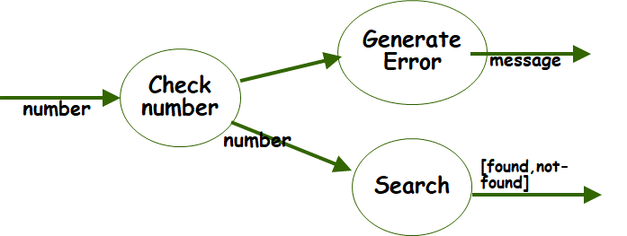

1. Unbalanced
2. Presence of synchronous data flow
3. Presence of asynchronous data flow
4. Presence of control information
   * 1. Consider the sentence: A book has one or more pages. Which of the following best characterizes the relationship between the Book class and the Page class?
5. Inheritance
6. Specialization
7. Association
8. Composition
   * 1. Which one of the following characteristics of a class implies that the same message can evoke different responses by an object of the class.
9. Encapsulation
10. Polymorphism
11. Information Hiding
12. Inheritance
    * 1. Which one of the following is true of encapsulation?
13. Encapsulation helps in reuse since developers need not examine all the components that access a data internal to a component.
14. Encapsulation means that software components can work more efficiently.
15. Encapsulation means that there is no need for software developers to document their work.
16. Encapsulation hinders reuse since data is not accessible to outside and hinders component to be reused.
    * 1. Code coverage analysis is used to measure which one of the following?
17. Thoroughness of testing
18. Bug density
19. Quality of code
20. Distribution of bugs
    * 1. Consider the following “C” code segment. At least how many test cases are needed for achieving decision coverage for the given C code?

**int main (){**

**inta,b=0;**

**scanf(“%d”,&a);**

**if( a < 10 || a>100)**

**b=b+10;**

**if( a == 20 )**

**b=b+20;**

**else**

**b++;**

**if( a == 30 )**

**b=b+30;**

**else**

**b=b+40;**

**}**

1. 3
2. 4
3. 8
4. 10
   * 1. If MC/DC coverage has been achieved on a unit under test, which one of the following test coverage is implicitly implied?
5. Path coverage
6. Multiple condition coverage
7. Condition/decision coverage
8. Data flow coverage
   * 1. What is the McCabe’s Cyclomatic complexity for the following code segment?

**int partition (intarr[], int l, int h){**

**int x = arr[h], i = (l - 1),t;**

**for (int j = l; j <= h- 1; j++) {**

**if (arr[j] <= x){**

**i++;**

**t=&arr[i]; &arr[i]=&arr[j]); &arr[j]=t;**

**}**

**}**

**t=&arr[i + 1]; &arr[i+1])= &arr[h]; &arr[h]=t;**

**}**

1. 2
2. 3
3. 4
4. 5
   * 1. Of the following, who typically conducts acceptance testing in a software development project?
   1. The development team
   2. The test team
   3. A set of friendly clients
   4. Customer
      1. Consider the following statement: “India shares borders with Pakistan, Bangladesh, and China.” Which one of the following types of class diagrams will be a suitable class model for this?
5. Unary association on Country class
6. Letting country class implement the Border interface
7. Country class aggregates Border classes
8. Unary dependency of Country class on Border class
   * 1. Which one of the following is a measure of the difficulty in achieving path coverage of the program?
   1. Number of statements in the program
   2. Number of decision statements in the program
   3. Number of the arithmetic expressions used in the program
   4. Time and space complexity of the program

**Question Paper Set 2**

**Instructions: There are three sections. Answer all questions from each section. Each question carries 2 marks.**

**Section A (Recall)**

For each of the following questions only one of the options is correct. Choose the correct option.

1. In the waterfall model of software development, which one of the following is not an exit criterion for the coding phase?
2. Unit testing is complete
3. Code review is complete
4. Integration testing is complete
5. Code documentation is complete
6. Which one of the following feedback paths is not present in an iterative waterfall model?
7. Design phase to feasibility study phase
8. Implementation phase to design phase
9. Implementation phase to requirements specification phase
10. Design phase to requirements specification phase
11. Which one of the following activities is performed during requirements analysis?
12. Identify requirements.
13. Build a prototype.
14. Identify any ambiguity, inconsistency, and incompleteness in the gathered requirements
15. Analyze and allocate resources for requirements specification
16. Which one of the following project characteristics indicates suitability of the RAD (Rapid Application Development) model of software development?
17. Few plug-in components are available
18. High performance or reliability required
19. Performance and reliability are not critical.
20. The system cannot be modularized.
21. Which one of the following is not a requirements gathering technique?
22. Task analysis
23. Scenario analysis
24. Form analysis
25. SRS document review
26. Which one among the following is the most desirable type of module coupling?
27. Control coupling
28. Stamp coupling
29. Data coupling
30. Content coupling

A data flow diagram represents which one of the following?

1. The conditions based on which data items may be processed
2. The order in which different activities are carried out
3. The transformation of data through processing stations
4. The order in which various functions of a program are invoked

Which one of the following is achieved by developing a sequence diagram during an object-oriented design process?

1. Identification of object state behavior
2. Determination of attributes of a class
3. Determination of inheritance relationships among classes
4. Assignment of responsibilities to classes

Which one of the following is true concerning software verification?

1. Helps answer the question: “Have you built the right thing?”
2. Checks the final product against the specification.
3. Usually carried out by the test team.
4. Checks whether an artifact produced in a phase conforms to the corresponding artifact produced in a previous phase.
5. Which one of the following is not true of monkey testing?
   1. Many program parts may not get tested.
   2. Risky areas of a program may not get tested.
   3. The tester can easily reproduce any failures
   4. Easy to generate test values

**Section B**

For each of the following questions only one of the options is correct. Choose the correct option.

Which one of the following phrases would most appropriately complete the sentence: “The later a defect is found, __________ .”

* 1. the easier it is to find
  2. the more expensive it is to repair
  3. the less important it is to the product
  4. the faster it can be fixed

For a typical software product, testing should account for what percentage of the total software development costs?

* 1. 5-10
  2. 10-20
  3. 40-50
  4. 80-90

Which one of the following types of program constructs is not essential for writing code for any arbitrary programming project?

1. Unstructured control flow
2. Sequence
3. Selection
4. Iteration

Which one of the following is **not true** of structured programs as compared with unstructured programs?

1. Structured programs are easier to read and understand
2. Structured programs are easier to maintain,
3. Structured programs are require less effort and time for development.
4. Structured programs have better run-time efficiency

Which one of the following is not an advantage of object-oriented development of programs over procedural development of programs?

1. Increased Reuse possibilities
2. Lower development time and cost
3. More efficient code
4. Easier maintenance

Which one of the following statements concerning the evolutionary model of software development is **FALSE**?

* 1. Software developed over several “mini waterfalls”.
  2. It involves a series of plan a little, design a little, and code a little.
  3. Outcome of each iteration is a tested, integrated, executable system.
  4. The number of iterations to be carried out is fixed at the beginning.

Which one of the following statements is not true of a data flow diagram (DFD) model?

1. It is a hierarchical diagram.
2. It represents code structure
3. It does not represent decisions and control flows.
4. It represents decomposition of functions and data into finer forms.

Which one of the following is a fault-based program testing technique?

* 1. Pair wise testing
  2. Dataflow testing
  3. Path testing
  4. Mutation testing

Which one of the following is an example of a negative test case?

* 1. A test designed to crash the software
  2. A test designed with negative integral values
  3. A test case causing software failure
  4. A test case with values outside the valid range of values

Which one of the following attributes of a program can be inferred from its Cyclomatic complexity?

1. Computational complexity
2. Lines of code (LoC)
3. Executable code size
4. Understandability

Consider the statement: "An employee is either a worker or a manager." Assuming that Employee and Manager to be two classes, what can be said about the relationship between these two classes?

1. Association
2. Generalization-specialization
3. Aggregation
4. Composition

Which one of the following is not a goal of requirements analysis?

1. Weed out ambiguities in the requirements
2. Weed out inconsistencies in the requirements
3. Weed out non-functional requirements
4. Weed out incompleteness in the requirements

For the following decision statement, at least how many test cases are needed for the given C code for achieving basis condition coverage?

**if((a>50) && (b<20) && (c==0) || (d==5)) p++;**

1. 2
2. 6
3. 8
4. Basis condition coverage is not achievable for the given code

Which one of the following is not a shortcoming of the waterfall model when used in present day software development projects?

1. Iteration among phases
2. Early and complete requirement specification
3. Integration and system testing late in the life cycle
4. Milestones mostly concern production and review of documents

Which one of the following most accurately reflects the style of software development that takes place in an agile software development project?

1. Incremental development
2. Iterative development
3. Linear development
4. Both incremental and iterative development

**Section C**

For each of the following questions only one of the options is correct. Choose the correct option.

Which one of the following activities is not carried out during the testing phase of the waterfall life cycle model?

1. Unit testing
2. Integration testing
3. System testing
4. Debugging

In the prototyping life cycle model, which one of the following is the principal reason for developing a prototype?

1. It can be used as an early production tool.
2. It may serve as a performance benchmark for the completed software.
3. It allows the customers to provide feedback about requirements.
4. It reduces the schedule for development through alpha testing of the prototype.

Which one of the following is the most plausible reason as to why unrestricted use of GO TO statements is normally avoided while writing a program.

1. It increases the running time of programs
2. It increases memory requirements of programs
3. It results in larger executable code sizes
4. It makes debugging difficult

Prototyping life cycle model can be recommended for a project suffers from which one of the following types of risks?

1. Schedule slippage
2. Manpower turnover
3. Incomplete and uncertain requirements
4. Poor quality of outsourced work

Which one of the following is not a factor explaining why software development using a high-level programming language takes less time and effort as compared to development of the same software using an assembly language?

1. Using a high-level language, it is easier to write structured programs as compared to writing the same software using assembly language.
2. When software is developed using high-level language, reuse of code is easier
3. When software is developed using high-level language, testing the full software is easier
4. When software is developed using high-level language, when any test case fails during testing, debugging the software is easier

Which one of the following statements does not identify a factor that contributes to making code reuse easier when high-level language is used as compared to when assembly language is used?

1. It is easier to write modular programs when using high-level language
2. High-level code is machine-independent
3. Assembly code is more difficult to understand
4. Each high-level statement typically corresponds to several assembly statements.

In the V model of software development, during the detailed design stage, test suite for which one of the following types of testing is designed?

1. Unit testing
2. Integration testing
3. System testing
4. Performance testing

Which one of the following statements concerning the V model of software development is **FALSE**?

1. Does not support overlapping of phases
2. Does not handle iterations among phases
3. Does not easily accommodate later changes to requirements
4. Testing activities are confined to later stages

Which one of the following is true of unary association?

1. It is defined between multiple classes
2. It is defined on exactly one object
3. It is defined between multiple objects of the same class
4. It is defined between multiple objects of different classes

In the prototyping model of software development, which one of the following is not a reason for developing the prototype of the software to be developed?

1. Learning by doing: useful where requirements are only partially known
2. Improved communication between the development team and the customer
3. Improved user involvement
4. The developed prototype is refined into the final working software

Which one of the following is not a type of difficulty faced by a project team while using an iterative waterfall model for software development?

* 1. Difficulty in accommodating change requests during development.
  2. High cost incurred in developing custom applications.
  3. Heavy weight process.
  4. Frequent requirements change makes development unstable

Which one of the following advantages is usually not expected while using the evolutionary process model in a software development project?

* 1. Better management of changing requirements.
  2. Customer feedback is obtained regularly and are incorporated efficiently.
  3. Customer training starts much before the final version of the software is released
  4. Highly reliable software is realized and therefore suitable for development of safety-critical software

During DFD (Data Flow Diagram) construction, which one of the following is achieved by balancing of the DFDs?

1. Data flowing into or out of a bubble must match the corresponding data flows at the next level of DFD.
2. Data flowing into a bubble must match the data flowing out of the bubble
3. Data flowing into or out of a bubble must match the data flows to the other bubbles
4. Data flowing into a bubble must match the data flowing out of the bubble

What is wrong with the following context diagram?

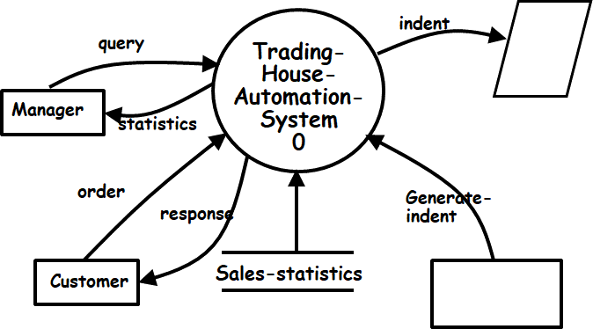

1. External entities are appearing at the context level
2. Input/Output occurring at the context level
3. Data item name missing on a data flow arrow
4. A data store appearing at the context level

The modules in a good software design should have which one of the following characteristics?

1. High cohesion, low coupling
2. Low cohesion, high coupling
3. Low cohesion, low coupling
4. High cohesion, high coupling

What would be the Cyclomatic complexity of the following program?

**int find-maximum(int i, int j, int k){**

**int max;**

**if(i>j) then**

**if(i>k) then max=i;**

**else max=k;**

**else if(j>k) max=j**

**else max=k;**

**return(max);**

**}**

1. 2
2. 3
3. 4
4. 5

At least how many test cases are required to achieve basic condition coverage of the following code segment:

**If((a>5) and (b<100) and (c>50)) x=x+1;**

1. 1
2. 2
3. 3
4. 4

Suppose an untested program was determined to contain 640 bugs. Three different testing techniques were applied to test the code. Each testing technique is effective to detect 50% of the bugs that exist before the concerned testing technique is applied. While fixing a bug after the application of a test strategy, there is a 50% chance of creating another bug. How many bugs would exist in the code after the three testing and bug-fix cycles have been carried out?

1. 200
2. 270
3. 350
4. 448

If two code segments have Cyclomatic complexities of N1 and N2 respectively, what will be the Cyclomatic complexity of the juxtaposition of the two code segments?

1. N1+N2
2. N1+N2+1
3. N1+N2-1
4. N1*N2

For the following program statement, which one of the following test suites would achieve basic condition coverage?

**if (a>10 && b<50) p++;**

1. (a=20,b=10), (a=0,b=15)
2. (a=20,b=10), (a=0,b=15), (a=5,b=45)
3. (a=50,b=20), (a=0,b=35)
4. (a=50,b=20), (a=1,b=85)

Consider the function **find-intersection(m1,c1,m2,c2)** that computes the point of intersection of two straight lines of the form **y=mx+c**. For equivalence class testing, at the first level of the equivalent class hierarchy the valid and invalid equivalence classes can be formed. The valid set of input values can be further divided into how many equivalence classes?

* 1. 1
  2. 2
  3. 3
  4. 4

Which one of the following can be said of a sequence diagram?

1. It is used to model the behavior of a single object when many use cases are executed
2. It is used to model the behavior of several objects when a single use case is executed
3. It is used to model the behavior of a single object when a single use case is executed
4. It is used to model the behavior of several objects when many use cases are executed

At least how many test cases are required to achieve MC/DC coverage of the following code segment:

**If((a>5) or (b<100) or (c>50)) x=x+1;**

1. 1
2. 2
3. 3
4. 4

Cause-effect test cases are, in effect, designed using which one of the following types of testing techniques?

1. Decision-table based testing
2. Coverage-based testing
3. Fault-based testing
4. Path-based testing

What is the number of controller classes required for a software development project whose use case diagram is shown below?

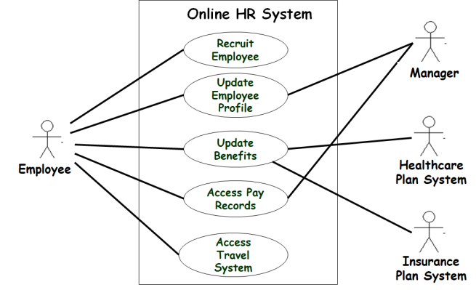

* 1. 3
  2. 4
  3. 5
  4. 6